HONG KONG AIR CADET CORPS 香港航空青年團

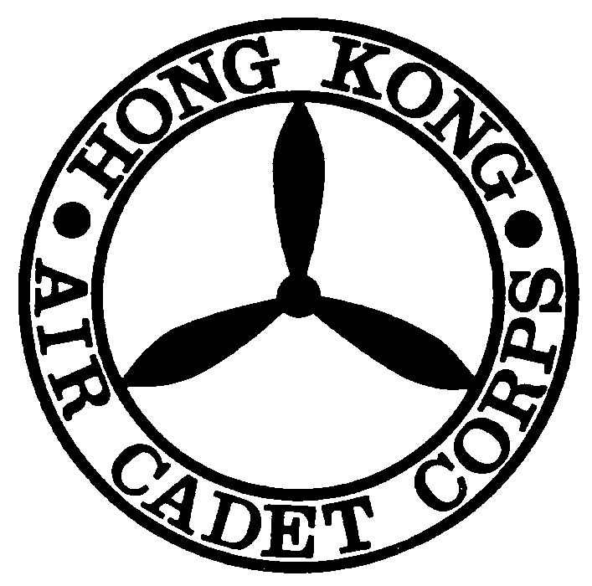
Application for Equipment Loan Form 物品借用申請表格

This Application must reach Headquarters 14 days before the Activity Date
此申請表格必須在活動日期前十四日到達總部

Please read notes before completion 填寫前請先閱讀摘要

Serial No. ___________
Day of Application (申請日期): ______________________
Applying Unit (申請單位): _________________________________________________________________
Title of Activity (活動名稱): _________________________________________________________________

Nature of Activity (活動性質): _________________________________________________________________
Number of Participants (參加人數):____________________________________________________________
Duration of Activity (活動時限): From (由) _____________________ To (至)________________________
Activity Approved by (批核活動單位): ________________________________________________________
Responsible Officer (負責長官): ____________________________________________________________

Signature Name Rank
Loan Items (借用物品)
No. | Items 物品名稱 | Quantity 數量 |  |  | Remarks  備註
No. | Items 物品名稱 | Applied  申請 | Approved  批核 | Returned  交回 | Remarks  備註
1.
2.
3.
4.
5.
6.
7.
8.
Total Number of Items

Contact Person (聯絡人): Name: ____________________
Rank:______________ Sqn / Unit:________________ Contact Tel No.:_____________

I would like to collect these equipment on __________(date) ___________(AM/PM)

Loan approval Officer: ___________________________________________________ _______________
(批核長官) Signature Name Rank Date

Signature of Collecting Officer: ____________________________________________ ______________
(物品收取人) Signature Name Rank Date
Notes:
- Please fill in the Radio Loan Form if you would like to borrow Walkie Talkie
- This Loan Form must be completed in full. Incomplete form will not be entertained.
- Items to be returned to Headquarters within 3 working days after the reported activity. Returned items must be CLEAN and DRY.
- All Gas Stoves and Lanterns must be detached from the gas container on return.
- All damage and loss must be reported on the “Report on Damage/Lost Form”
- Payment for damage and loss is at the decision of OC Supply Flight.

