HONG KONG AIR CADET CORPS 香航空青年團
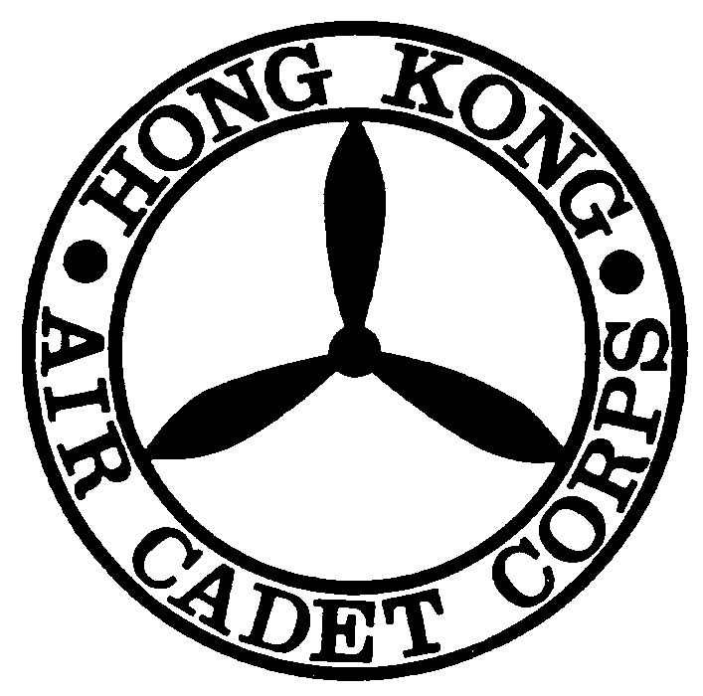
Report on Damage / Loss Form 物品損壞/遺失報告表格

This Report Form must reach Headquarters 3 days after the completion of the Activity
此申請表格必須在活動完結後三日內到達總部

Please read notes before completion 填寫前請先閱讀摘要

Serial No. ___________
Date of Report (申報日期): ______________________
Reporting Unit (申報單位): _________________________________________________________________
Title of Activity (活動名稱): _________________________________________________________________
Reporting Officer (申報長官): _________________________________________________________________

Signature Name Rank
Contact Person (聯絡人): __________________________ Contact Phone (聯絡電話):______________

Damage / Lost Items (損壞/遺失物品)
No. | Items 物品名稱 | Quantity  數量 | Reason of Damage / Lost  損壞/遺失原因
1.
2.
3.

Inspecting Officer: ________________________________________________________ _______________
(檢查長官) Signature Name Rank Date

Recommendations on Damage / Loss (損壞/遺失建議) Replace (賠償) / Waived (不須賠償)

Authorizing Officer: ________________________________________________________ ____________
(授權長官) Signature Name Rank Date
Notes
Method of Replacement:
- To replace the Damaged / Lost Item(s) by yourself.
- To replace the Damaged / Lost Item(s) by Supply Flight. A 20% Supply Charge will be added to the Total Cost.
- All replacement should be the same or nearest the same as the Damage / Lost Item(s) in both features and qualities.
- Before the completion of replacement, Unit’s RIGHT TO LOAN will be Temporarily Suspended.
Report on Damage/Lost Form (Admin.5A 09/99)

