HONG KONG AIR CADET CORPS 香港航空青年團

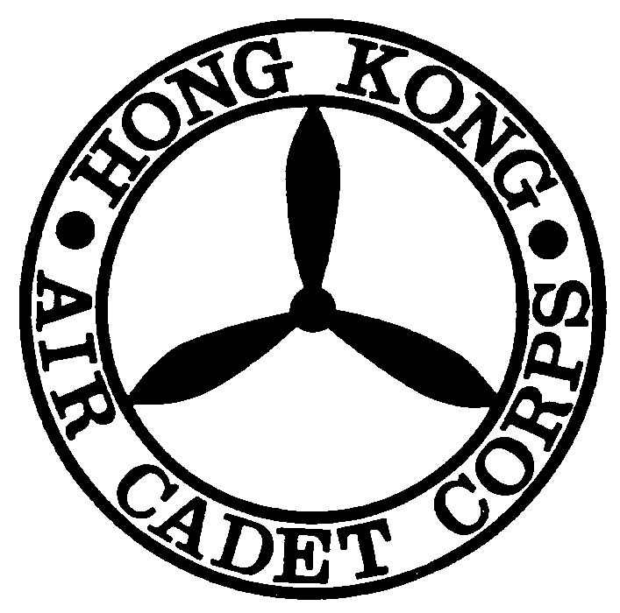
Name Card Order Form

Please read notes before completing the form 填寫前請先閱讀摘要
To: AO
Official Use
Proof of payment enclosed by *cheque / bank-in slip total amount received $ __________ .
Handled by : _______________
Request being * approved /rejected
Date: ____________________
Receipt No.: ______________
Remarks: _________________
*Delete as appropriate

From:
Phone Number:
E-mail:
Signature:
Date:

General Information ( All details should be typed or marked clearly.)
 | Surname  (e.g. CHAN) | Given Name  (e.g. Tai Man William)
Name in English
中文姓名
Contact Number | (Please put N/A if you wish to use HQ contact: 2712 8900)
Fax | (Please put N/A if you wish to use HQ contact: 2715 6944)
Email | (Please put N/A if you wish to use HQ contact: hq@aircadets.org.hk)
Rank
Current Posting in HKACC | (e.g. Officer Commanding No219 Squadron)
Honours  (e.g. BBS) | (Please put N/A if you wish to leave this blank)
Education Qualifications  (e.g. BSc (HK)) | (Please put N/A if you wish to leave this blank)
Professional Qualifications  (e.g. FCCA) | (Please put N/A if you wish to leave this blank)
Detail of order
I would like to order *100 / 200 / 300 pieces of name card and understand that payment has to be settled before sending in the order request.

Notes:
- Price of 100, 200, 300 pieces are $90, $100 and $110 respectively.
- Please settle the payment BEFORE placing the order by
(i) a crossed cheque payable to “Hong Kong Air Cadet Corps” or
(ii) bank in exact fee into HSBC account : 808-620280-002
- Please submit the bank pay-in slip (true copy) or cheque with this order form to HQ while placing order.

