- 香港航空青年團
- HONG KONG AIR CADET CORPS
- Sung Wong Toi Road, Kowloon, Hong Kong
- Tel 852 2712 8900 Fax 852 2715 6944
From: | OC E&M Flt, SD Wg, SD&S Gp | To: | All OC Major Units
Ref: | (01)/EWS/2019 | Cc: | DCO SD&S, OC SD&S Gp, OC SD Wg
Email: | acc.exped@gmail.com | Date: | 10 April 2019

Expedition & Mountaineering Workshop Series:
Project Pioneer (先鋒工程)
To foster the enhancement of outdoor skills, in particularly the campsite establishment and knotting of our fellow members, E&M Flt will organise a Project Pioneer this year with details below. With solid knotting skills, you may build creative and beautiful camp craft!
Date: | 5th May 2019 (Sunday)
Time: | 10:00 -17:00
Theme: | Knotting Course
Location: | Music Farm, Shui Tau Tsuen, Kam Tin (錦田音樂農莊)
Transportation: | Self-transport (*Please refer to Appendix I)
Activity fee: | $50 /person (*Fee will be collected during roll call time)
Dress code: | Corps Polo Shirt/ Squadron Tee, Long pants & Sports shoes
Target participants: | All members are welcome
Quota: | 20 (*first come first served basis)
Instructor: | SEI (CI Tommy AU-YEUNG) & EIs
Note: | - Equipment:  Working gloves, drinking water and scout rope  - Lunch arrangement:  Option 1: You can bring your own packed lunch  Option 2: You can bring you own food and stove to cook / using the pizza oven in Music Farm
Interested members please return the attached reply slip (Appendix II) in MS Word format by email to acc.exped@gmail.com by 2359 hrs 24th April 2019 (Wednesday) for application.

Fg Off Philip C Y WONG
Officer Commanding Expedition and Mountaineering Flight

Appendix I - Transportation
By Minibus: Route no.601
- Travel from Kam Sheung Road Station to Kam Tin Country Club (錦田鄉村俱樂部)
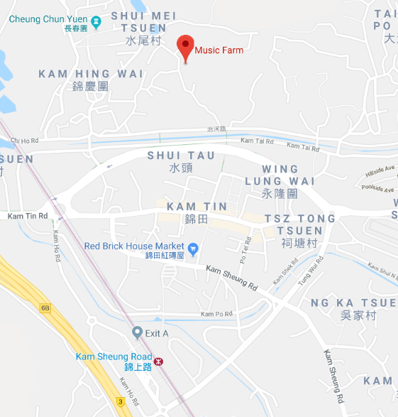
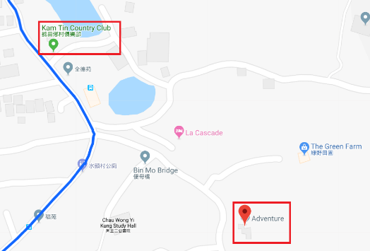
- Five-minute walk from the drop-off point and you will arrive the music farm
Music Farm
錦田音樂農莊

Get off from minibus no. 601

Appendix II - Reply Slip - Project Pioneer (先鋒工程) – 5th May 2019
Email to: acc.exped@gmail.com
To: OC E&M Flt
From: ____________ Sqn/Unit
List of application
No. | Rank | Name | Chinese name | Serial No. | Gender | Age | Lunch arrangement (Option 1/2) | Mobile phone no. | Emergency Contact Person and Phone No. | Special Health Conditions/ Notes
e.g. | BC | CHAN Siu-man | 陳小文 | M13-45678 | M | 16 | Option 1 | 9876 5432 | CHAN Tai-man  9123 4567 | N/A
1
2
3
4
5
6
7
8
9
10
Signature: _____________________
Post: _____________________
Rank and name: _____________________
Contact No.: _____________________

