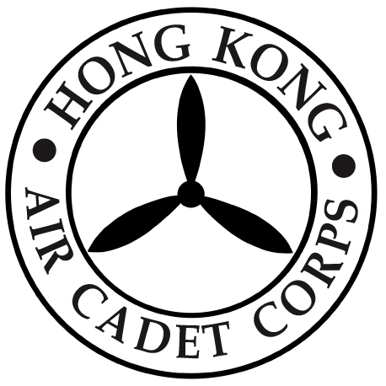
HONG KONG AIR CADET CORPS

Annual General Meeting Attendance Reply Slip

(Please confirm your attendance on or before noon, Friday, 1 December 2023)

To : Administrative Manager, HQ
Fax: 2715 6944

* Please tick as appropriate

I. AGM attendance*

_________ I would like to confirm my attendance at the Annual General Meeting to be held on 7 December 2023.

_________ Please accept my apologies for my absence from the Annual General Meeting to be held on 7 December 2023.

Signature: ____________________ Date: _____________________

Rank & Name: ______________________ Post: ______________________

