由: 成人訓練科主管 | 至: 各單位主管
日期: 二零一四年九月二十五日 | 副本: 副司令(訓練)、 訓練部主管  及 訓練部副主管(II)

專業發展系列(十二月號) ： 制服團體中的青少年教育
成人訓練科之「持續訓練組」旨在為圑內各圑員提供全面性的持續教育及培訓，從而提升圑員在不同崗位上的領導、溝通及效率管理的能力。

我們誠邀各成年圑員參與本期的進修課程。我們很榮幸邀請了譚超雄先生，主講有關於制服團體中的青少年教育。譚先生為資深社工，擁有青少年義工輔導工作的豐富經驗。是次講座會討論如何利用制服團隊的特質去推行青少年教育及訓練，及如何讓青少年透過參與制服團體學習與人相處和合作。

講座詳情如下:
日期: 十二月七日(星期日)
時間: 下午三時至五時三十分
地點: 香港飛行總會Gotfried Room
(香港九龍宋皇臺道31號)
參加對象: 各階級之成年圑員
服飾: Corps Polo T-shirt
費用: 全免

有興趣之成年圑員請填妥報名表，並須獲得所屬單位主管的簽名許可。填妥之申請表格須於十二月五日前透過電郵 (atwg.hkacc@gmail.com) 交回持續訓練組。

如有任何查詢，請透過上述電郵與劉綺雯少尉聯絡。

成人訓練科主管
陳俊彥署理少校
二零一四年九月二十五日

講員簡介

譚超雄 (Ivan C H Tam) BSW, Chartered MIPD
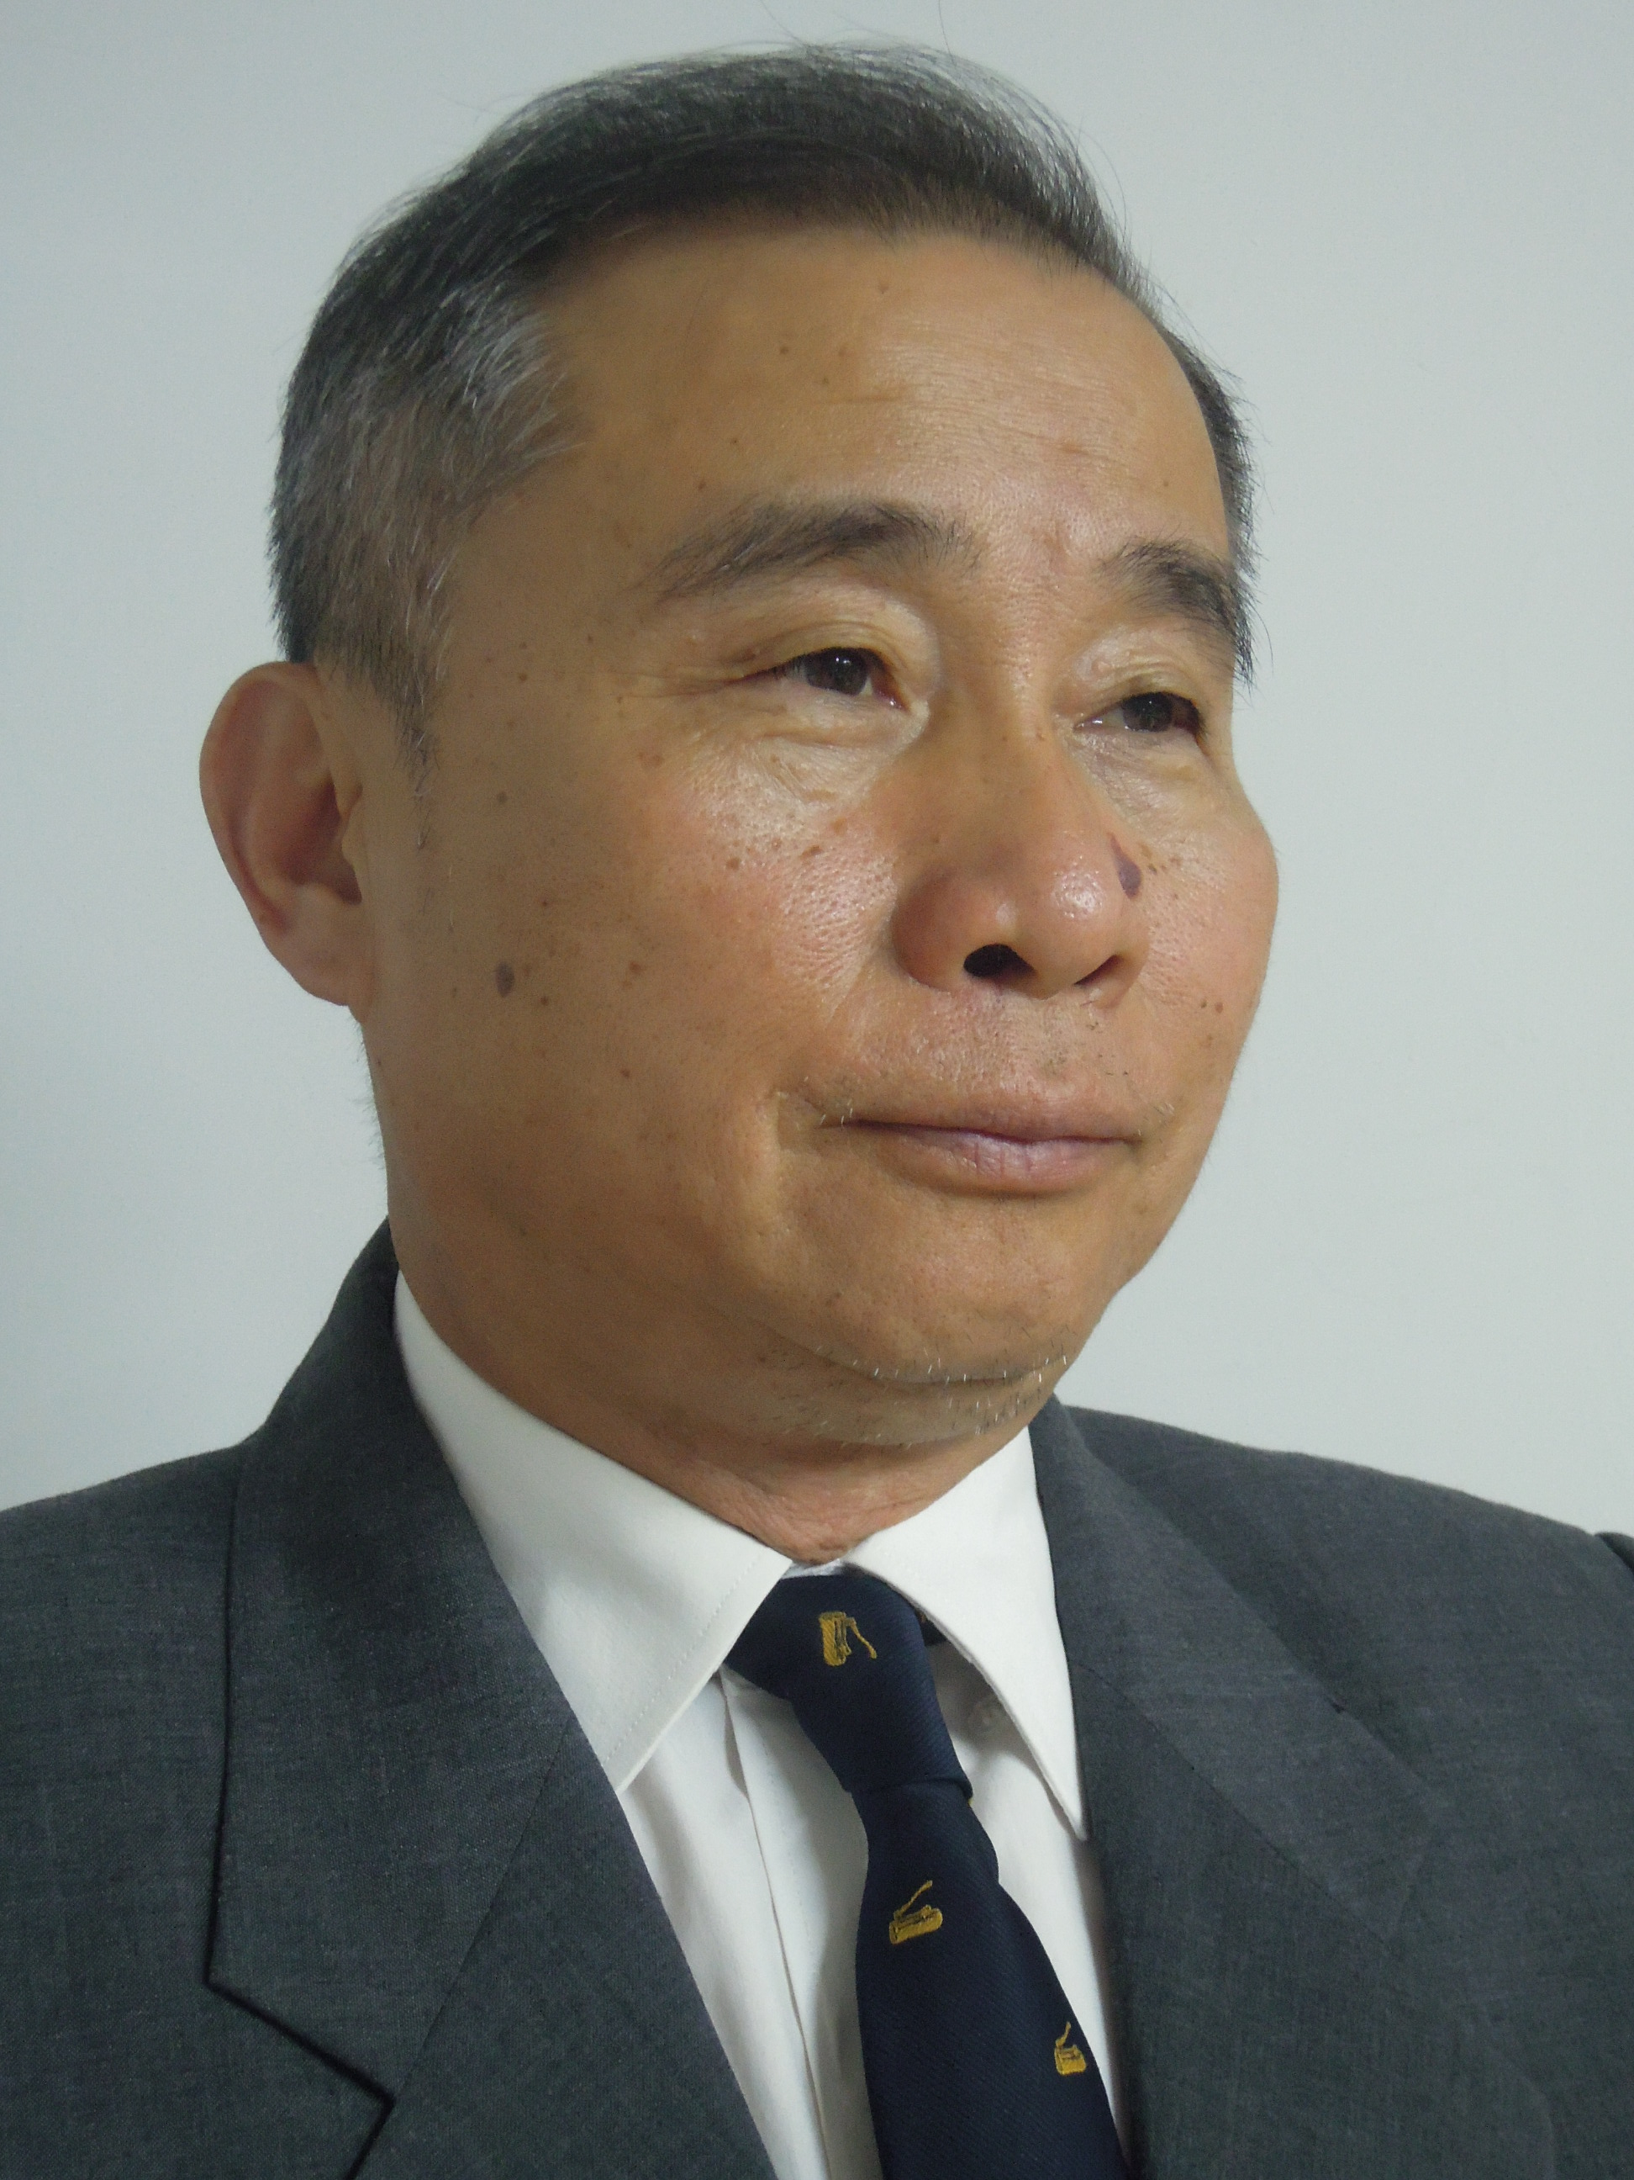
Senior Consultant, Wofoo Social Enterprises

Registered Social Worker of HKSAR
Visiting Professor, Capital University of Economics & Business, Beijing
Life Member, HK Social Workers Association
Leader Trainer, Scout Association of HK
Member of Expert Panel, Asia-Pacific Region, World Organization of
Scout Movement (WOSM)
Controller, Chinese Youth Exchange Centre
Chair, Board of Director, Street Sleeper Action Committee
Deputy Secretary General, the Joint Committee for the Promotion of the Basic Law of HK

Mr Tam is a veteran social worker, with ample experience in working with youth and the community. He got the Social Work Diploma and Degree in 1976 and 1987 respectively. He has close to 40 years of practice with social services & social enterprises. He has good experience in working with multiculturalism, communication, volunteering, vocational training & career support programmes. Mr Tam is also a committed volunteer working with the underprivileged, volunteerism and its development, Scouting and community advocacy programs (such as Homeless World Cup, Water Race etc.).

Refresher Course / workshop
Application Form

To: | OC AT Wg (Attn: OC ACT Flt)
Date:
From:

Participants’ information
# | Unit | Rank | Name | Serial No. | E-mail | Phone
1
2
3
4
5
6
7
8

Endorsed by ______________________
OC Unit

