香港航空青年團
HONG KONG AIR CADET CORPS
AVIATION EDUCATION WING
MEMO
From : OC AE Wg To : All OC Units
Ref : (4b) in AE/DACP2016 Cc : All Major OC Units
Date : 21 November 2015
Aviation Career Seminar cum
Introduction to Dragonair Aviation Certificate Programme (DACP) 2016

DACP 2016 will be open for application in November 2015. The captioned event aims at introducing the local aviation industry and providing a preview of DACP 2016 to fellow members. The enrolled list is as follow:

Date : Seminar II on 23 Nov 2015 (Mon)
Time: 1930-2200 hr
Venue: TU101, The Hong Kong Polytechnic University (map is attached in Appendix I)

 | Sqn unit | Rank | Name | S/N; Student Id
 | 604 | OT | MAN Ka-ki | O-3018
 | 604 | OT | TONG Chun-pong | M13-20862
 | 605 | OT | Yuen Kin Man | (new member)
 | 605 | OT | Ho Man Lee | (new member)
 | 605 | OT | Lam Hei Sun Hayden | (new member)
 | 607 | OT | WONG Tsz- yan | O-3515
 | 607 | OT | LIN Yu-gi | (new member)
 | 607 | OT | SUM Dick-ka | (new member)
 | 6009 | OT | CHAN Sze Man Sumina | O- 3389
 | 6009 | OT | CHENG Tsz Ho | O-3538
 | 6009 | OT | CHOI Wai Wan | O-3397
 | 6009 | OT | LEUNG Tik Wai | O-3523
 | 6009 | OT | KWOK Yuet Shan Iris | O-3543
 | 6009 | OT | KONG Siu Ling | M15-22962
 | 6009 | OT | LEE Yat Chun | M14-22330
 | 6009 | OT | TSENG Ho Yi Kevin | M14-22329
 | 6009 | OT | NG Hoi Lam | O-3552
 | 6009 | OT | NG Man Fung | O-3539
 | 6009 | OT | NG Man Tsun | O-3540
 | 6009 | OT | LIN Ho Chun | M14-22486
 | 6009 | OT | WONG Yan Ho | O-3465
 | 6009 | OT | HO Shing Fung Barry | M15-22834
 | 6009 | OT | WONG Wai Chun | M15-22836
 | PolyU |  | CHAN Chun Yiu | 14078677D
 | PolyU |  | CHAN Ka Kit | 13066059D
 | PolyU |  | CHAN Kwok Ho | 15027035D
 | PolyU |  | CHAN Wan Yu | 13066653D
 | PolyU |  | CHEUNG Wai Kin | 12082213D
 | PolyU |  | HO Nathaniel | 15093077D
 | PolyU |  | KWOK Tsz Him | 14039434D
 | PolyU |  | KWONG Chin Cheung Jason | 14047812D
 | PolyU |  | LEE Gin Man | 14060088D
 | PolyU |  | LEE Siu Man | 13091175D
 | PolyU |  | LEUNG Chi Hin | 15083902D
 | PolyU |  | LEUNG Wai Chiu | 15083902D
 | PolyU |  | LEUNG Yik Hung | 15080078D
 | PolyU |  | LI Ka Ki | 14043106D
 | PolyU |  | LI Pak Yan | 13067125D
 | PolyU |  | LIN Man Yin | 13121292D
 | PolyU |  | LING Wudao | 12132496D
 | PolyU |  | MOK Yuk Ting | 14028574D
 | PolyU |  | NG Chor Hei | 14039289D
 | PolyU |  | NG Sze Wing | 15033037D
 | PolyU |  | NG Sze Wing | 14039098D
 | PolyU |  | Tam Chun Hei, Brandon | 11609331D
 | PolyU |  | THAI Thu Thao | 13092158D
 | PolyU |  | TSE Shing Yan | 12111851D
 | PolyU |  | WAN Chi Lok | 15051223D
 | PolyU |  | WONG Chi Kau | 15063409D
 | PolyU |  | WONG Chung Yan | 12121622D
 | PolyU |  | WONG Tin Chi Timothy | 11002829D
 | PolyU |  | WU Yu-han | 13101195D
 | PolyU |  | YIP Ho Yin Alex | 14034935D

For enquiries, please feel free to contact the undersigned with email. (address: hkacc.aewing@gmail.com)

Charlotte HUNG
Ag Plt Off
for OC AE Wg

Come to our facebook page and obtain the latest information about AE Wg at:
http://www.facebook.com/hkacc.aewing
Appendix I
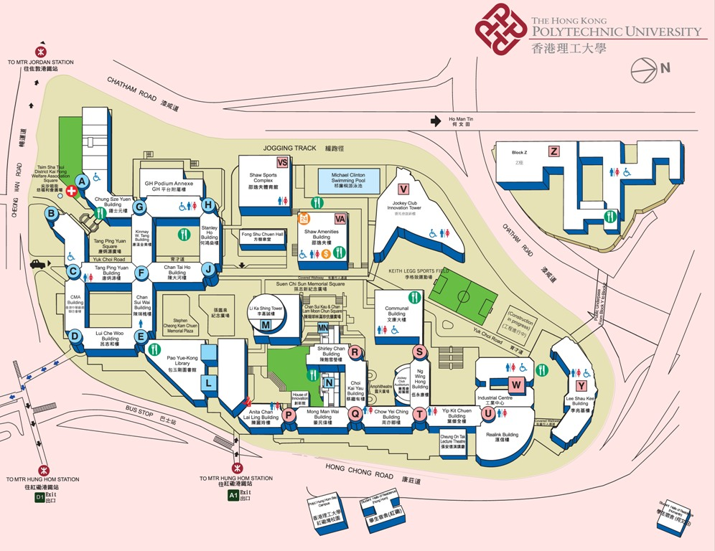
TU101

