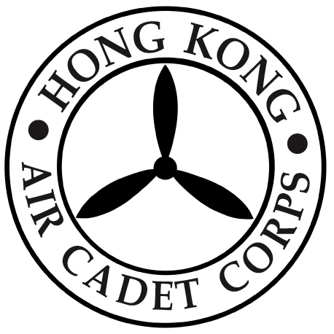

HONG KONG AIR CADET CORPS

From: HQ  Ref: GR23_017 | To: All members on the active list  Cc: DCOs and OC Gps
Tel: 2712 8900  Fax: 2715 6944 | Date: 2 June 2023

Invitation for applications: Personal Assistant to Commanding Officer

Applications are now invited from suitably qualified young officers for the post of Personal Assistant to Commanding Officer (PA to CO) as a secondary appointment to aid the Commanding Officer in discharging his duties. Intended to be a comprehensive learning experience to the appointee to prepare him/her for higher responsibilities in the future, a tour of duty will normally last for two years, during which the appointee will continue serving in his/her primary posting on a concurrent basis.

Applicants should be an active duty Flt Lt or Fg Off:
(a) With a mature and outgoing personality, excellent service knowledge;
(b) A proven track record of commitment and devotion to the Corps;
(c) Well versed in service etiquette; and
(d) Possessing excellent communication skill and good common sense.

Applications with full cv should reach the Commanding Officer by email ( co@aircadets.org.hk ), with endorsement by the Deputy Commanding Officer (or equivalent) in charge of the group under which the candidate is serving. Closing date is 3 July 2023.

CHAN Man Lang
Gp Capt
Commanding Officer

