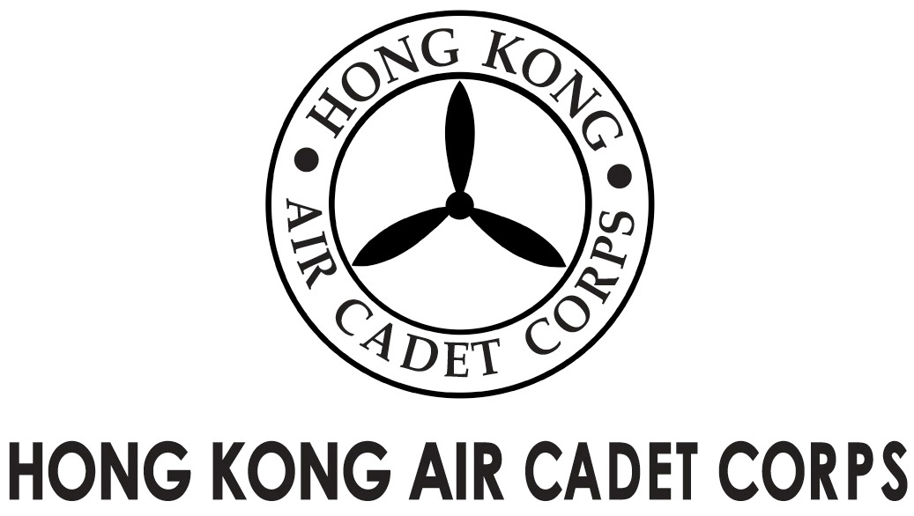
ADMINISTRATION AND SUPPORT GROUP.

From | Adjt A&S Gp / OC PA Flt  (michael@etoileam.com) | To | All OC units
Our Ref | ITEHK/2014/1 | # of Pages | 1
Date | 29/5/2014 | Your Ref

Unit Promotion in ITEHK 2014 Sport Tourism Pavilion
Hong Kong Air Cadet Corps will be one of the exhibitors of ITEHK 2014 Sport Tourism Pavilion (http://www.itehk.com/ITEHK/) which will be held between 12-15th June, 2014 at the Hong Kong Convention and Exhibition Centre.

The exhibition booth will be opened to all units, including squadrons, to introduce themselves to the public and recruit new members. Interested parties please reply your time slot preference (up to 3 sessions) to pa@hkacc.info on or before 6th June, 2014.

 | 12/6(Tue) | 13/6(Wed) | 14/6(Sat) | 15/6(Sun)
1000 - 1200
1200 - 1400
1400 - 1600
1600 - 1800 |  |  |  | (*till 1700)

For further enquiries please feel free to contact us at pa@hkacc.info.

(Signed on original)

Lisa ZHOU
Plt Off
For OC PA Flt

