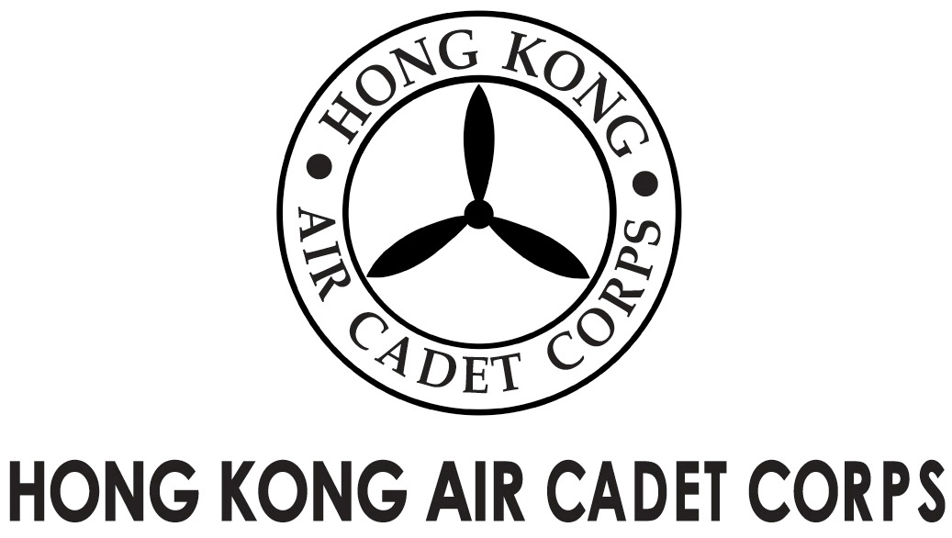
ADMINISTRATION AND SUPPORT GROUP.

From | Adjt A&S Gp / OC PA Flt  (michael@etoileam.com) | To | All OC units
Our Ref | PhotoStory/2014/3 | # of Pages | 1
Date | 5/11/2014 | Your Ref

Photo Story Campaign – Aug Result
The Photo Story Campaign has been started in Aug and we have our first winner in “HKACC” Category. Congratulations to Sgt Instr PANG Chun-ho (O-2416). Sgt Instr Pang will be awarded $200 book coupons, certificate and a hardcopy of the calendar.

There are 11 more winners going to be chosen at the end of the campaign. All members of HKACC are welcomed to join the campaign. Don’t hesitate! Submit your story with a photo to show your passion in aviation and HKACC! For the detail of the Photo Story Campaign, please refer to the latest memo “PhotoStory_memo_update(Nov)”.

For further enquiries please feel free to contact us at pa@hkacc.info.

(Signed on original)

Lisa ZHOU
Plt Off
For OC PA Flt

